[Pillo: Personal Home Health Robot](https://www.indiegogo.com/projects/pillo-your-personal-home-health-robot-family-technology)

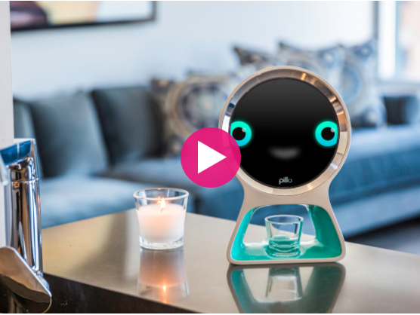$103,958 USD total funds raised

135% funded on August 6, 2016

Pillo empowers people of all ages to better manage their health. He can answer your health and wellness questions, connect you directly with healthcare professionals, and securely manage your vitamins and medication; storing, dispensing, and even ordering refills when you need them. And he's intelligent, so his functionalities will grow as he learns about you and your family.

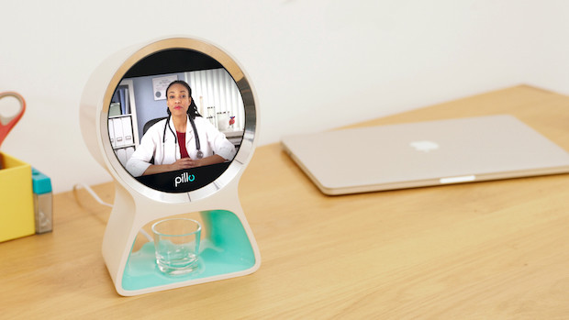

Pillo securely stores up to four week's worth of vitamins and medications in tamper proof containers within the device. And with his sophisticated identity recognition technologies, Pillo makes sure that medications are dispensed for the right user at the right time, every time. [Pills are only distributed if users passes face and voice recognition.] He can also send you or your caregivers reminders if you need a little help staying on schedule. Running low? Not to worry. Pillo knows and will automatically re-order your medications from your preferred pharmacy *(especially useful for facilities with in-house pharmacies).*

The developers intend to add mobility & fall detection and baby monitor functions in the next software update.

**What languages does Pillo speak?**

Pillo speaks excellent English. We will build in additional languages in due course.

**What if I am soft spoken or have an accent?**

Pillo’s voice recognition capabilities are excellent. We’ve tested him across a range of voice tonalities and accents.

**Does Pillo require Wi-Fi connection?**

Yes, Pillo requires a working Wi-Fi connection.

**Can Pillo really recognize me?**

Yes! Our engineers have years of experience building and working with both voice and facial recognition software. Pillo will be able to see you from several feet away. His omnidirectional microphones mean that he’ll be able to hear you from anywhere in the room.

**What kind of questions can I ask Pillo?**

You will be able to ask Pillo all sorts of health and wellness related questions. We are integrating Pillo into several verified and well respected online databases in areas such as medicine, nutrition, diet, and more. That way you can be sure that the information you receive from Pillo is of the highest quality.

**How many different profiles can be set up on Pillo?**

Pillo has been designed to be used both by individuals and by families. You can set up as many profiles as you like on the device. However, bear in mind that the more users you add to the device, the fewer pills-per-user Pillo will be able to store.

[Amazon Echo (Alexa)](https://www.amazon.com/Amazon-Echo-Bluetooth-Speaker-with-WiFi-Alexa/dp/B00X4WHP5E)

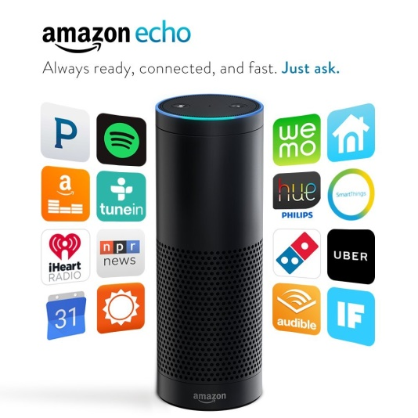Amazon Echo is a hands-free speaker you control with your voice.

“Far-field voice recognition” – seven microphones and beam forming technology so it can hear you from across the room—even while music is playing.

Plays all your music from Prime Music, Spotify, Pandora, iHeartRadio, TuneIn, and more using just your voice

Fills the room with immersive, 360º omni-directional audio

Allows hands-free convenience with voice-control

When you want to use Echo, simply say the wake word, "Alexa," and Echo lights up and streams audio to the cloud, where the Alexa Voice Service is leveraged to recognize and respond to your request instantly.

Answers questions, reads audiobooks and the news, reports traffic and weather, gives info on local businesses, provides sports scores and schedules, and more using the Alexa Voice Service

Alexa—the brain behind Echo—is built in the cloud, so it is always getting smarter. The more you use Echo, the more it adapts to your speech patterns, vocabulary, and personal preferences.

**The** [**Wire Cutter**](http://thewirecutter.com/reviews/what-is-alexa-what-is-the-amazon-echo-and-should-you-get-one/#how) **review:**

Amazon built a natural language processing system [called Alexa] that is one of the easiest to interact with we’ve seen. If you ask a question or deliver a command, you usually don’t have to ask twice. Part of Alexa’s success is dependent on the seven very sensitive microphones built into both the Echo and Dot (the Tap, being a portable version, works a little differently). Alexa is always listening, and is quick to respond. As noted earlier, Echo and Dot only stream your voice to the cloud when you ask it to do something (your requests also show up in the app, and you can delete them if you don’t want to leave a record). The default wake word is “Alexa,” but you can change that to “Echo” or “Amazon.” Once you say the magic word, the microphone takes everything you say next and beams it up to Amazon’s cloud computers for quick analysis.

[Google Home](https://home.google.com/)

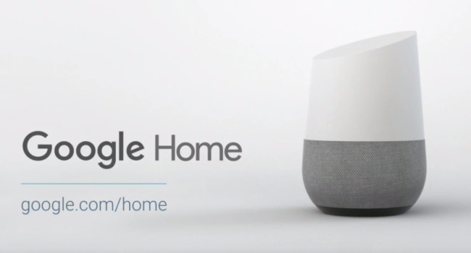Google Home is a voice-activated home product that allows you and your family to get answers from Google, stream music, and manage everyday tasks.

[**Tech Radar**](http://www.techradar.com/news/digital-home/5-reasons-google-home-will-beat-amazon-echo-1321967) **coverage:**

What is Google Home? Put simply it's a smart speaker, but one that's aimed at pulling together the big G's smart home offerings, both past and present. Not only that, it also draws from Google's formidable experience in search to offer information when you want it, where you want it.

[**Digital Trends**](http://www.digitaltrends.com/home/google-home-news/) **coverage**:

Google Home is a small, white, buttonless speaker with an angled top and modular base that comes in different colors to match your decor. And in all honesty, it’ll just be a Chromecast in disguise. This shouldn’t come as any huge surprise, as Mario Queiroz, who announced Google Home, was also behind the video-streaming device. Indeed, as [The Information confirms](https://www.theinformation.com/google-homes-little-secret), the core function of Home (like its microprocessor and Wi-Fi chip), will be identical to the insides of the Chromecast. “In other words,” The Information reports, “Home will essentially be a microphone, speaker, plastic top with LED lights, and a fabric or metal bottom — wrapped around a Chromecast.”

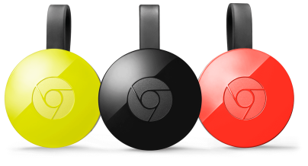**So what’s Chromecast?** [**Digital Trends**](http://www.digitaltrends.com/computing/chromecast-features/) **obliges:**

Here’s how casting works: Using apps on your mobile device or computer, you essentially hand off, or cast, content to the Chromecast. Using the information it receives about what you want to watch, the Chromecast finds the material on the internet and streams it directly from the source.

[Siri (iOS)](https://www.apple.com/ios/siri/)

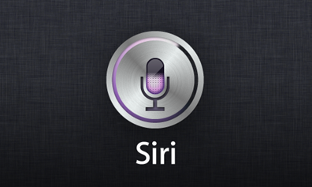Talk to Siri as you would to a friend and it can help you get things done — like sending messages, placing calls, and making dinner reservations.

“Aiesha Turner is my mom.” Tell Siri how people in your contacts are related to you, like your mom, dad, wife, or boyfriend, and it will know who you’re referring to the next time you ask Siri to contact someone.

“Learn to pronounce my name”. You can teach Siri how to pronounce your name correctly.

“Wake me up at 7AM tomorrow.”

“Move my 2pm meeting to 2:30.”

[New York Times](http://www.nytimes.com/2016/01/28/technology/personaltech/siri-alexa-and-other-virtual-assistants-put-to-the-test.html?_r=0) review:

Apple was the strongest at productivity tasks like calendar appointments and email; Google was the best at travel and commute-related tasks. Alexa excelled at music, and Cortana was mediocre across the board. Facebook was left out of the grading system because the company denied access to M,